**Practical 1**

**Q1**

**Q2**

**Q3**

**Q4**

**Q5**

**Q6**

**Q7**

**Q8**

**Q9**

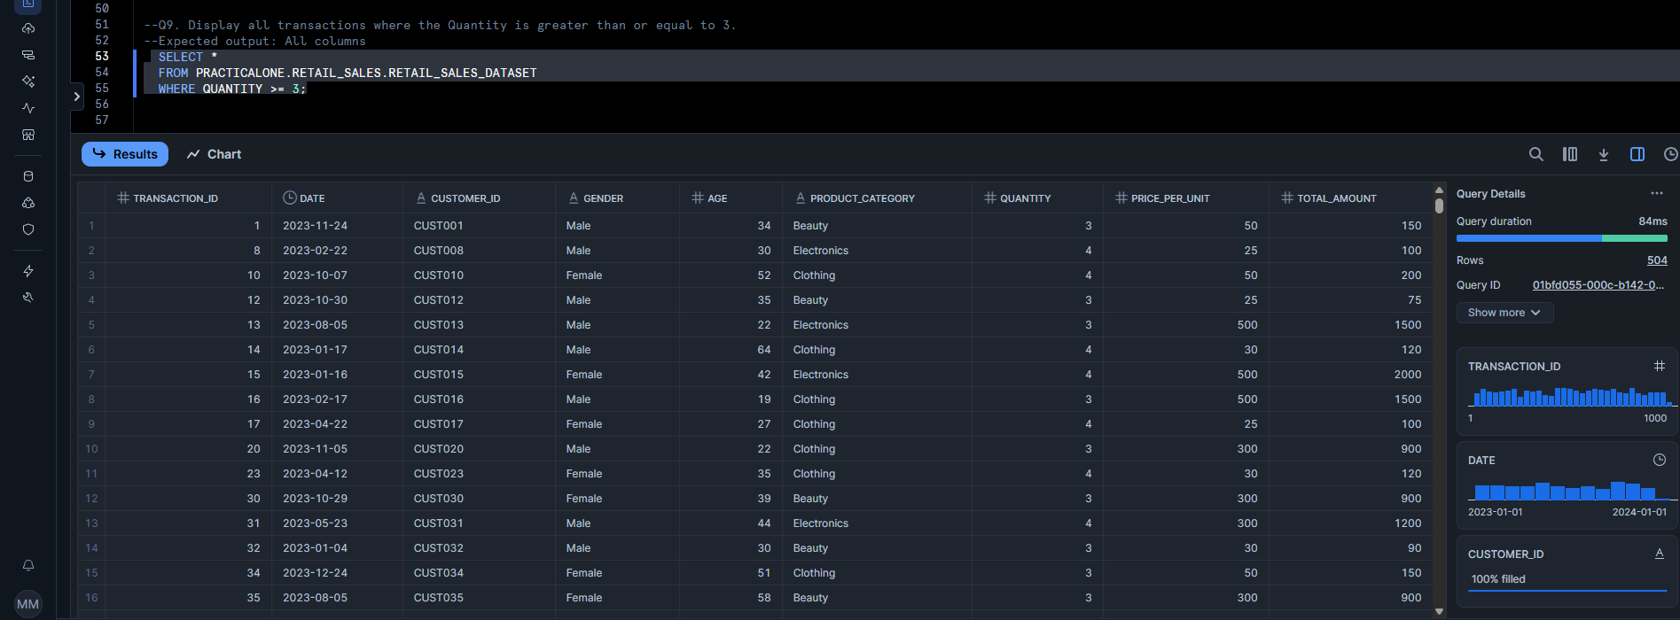

**Q10**

**Q11**

**Q12**

**Q13**

**Q14**

**Q15**

**Q16**

**Q17**

**Q18**

**Q19**

**Q20**

